
THE CROSSINGS
Apparel Order Form 2015 Champions

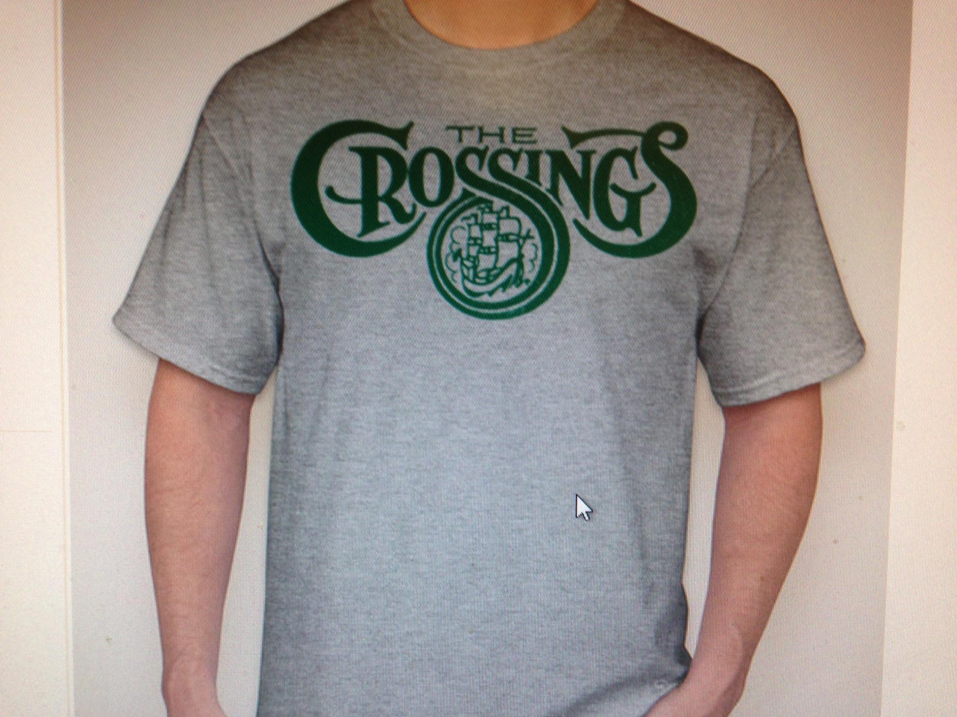
All items will come with the official Crossings logo printed on the front. You can view the items at www.companycasuals.com by putting style numbers in ( ) in the search box.
ITEM | COST
T-shirt (PC61): | $12.00
Long sleeve T-shirt (5400): | $16.00
Women’s T-shirt (LPC150)*: | $15.00
Women’s V-neck (DM1170L)* | $17.00
Dri-fit T-shirt (ST350): | $20.00
Hood sweatshirt (18500)* | $25.00


SIZES: Youth: Small, Medium, Large, X-Large.
Adult: Small, Medium, Large, X-Large, XXL, XXXL
*No youth sizes available
(Please add $2 each for XXL, and $3 each for XXXL)

Items available in white or gray with green imprint.

OPTION: Add “2015 Cranberry CUP Softball Champions” to shirt back $4

- Drop off orders to: Carrie Hetzel -- 900 Stonehenge Way
- Orders will be collected until WEDNESDAY, SEPTEMBER 9TH
- Make checks payable to: Carrie Hetzel
- Orders will be delivered sometime during the weekend of September 26th

ITEM SIZE COLOR Champion logo on back COST
Example: T-shirt XL gray Yes $16
1.
_________________________________________________________________________
2.
_________________________________________________________________________
3.
_________________________________________________________________________
4.
_________________________________________________________________________
5.
_________________________________________________________________________

$______________
TOTAL
Name:_______________________________________________

Address:_______________________________________ Phone ________________________

