
THE CROSSINGS
Apparel Order Form

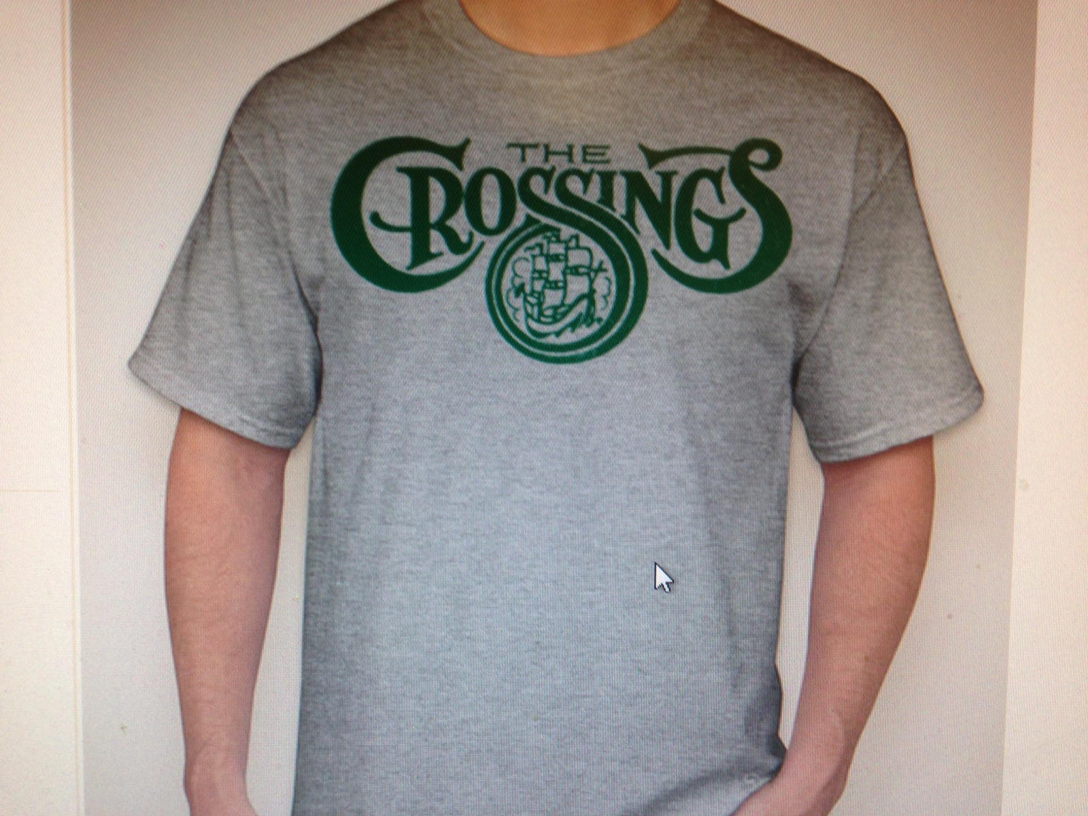
Show your neighborhood pride with the official CROSSINGS apparel. This is a one-time only order so don’t miss your chance. All items will come with the official Crossings logo printed on the front. You can view the items at www.companycasuals.com by putting style numbers in ( ) in the search box.

ITEM | COST
T-shirt (PC61): | $12.00
Long sleeve T-shirt (5400): | $16.00
Women’s T-shirt (LPC150)*: | $15.00
Dri-fit T-shirt (ST350): | $20.00
Hood sweatshirt (18500)* |   $25.00

SIZES: Youth: Small, Medium, Large, X-Large.
Adult: Small, Medium, Large, X-Large, XXL, XXXL
*No youth sizes available
(Please add $2 each for XXL, and $3 each for XXXL)

Items available in white or gray with green imprint.

OPTION: Add “2014 Cranberry CUP Softball Champions” to shirt back $4

Drop off orders to: Carrie Hetzel -- 900 Stonehenge Way
Orders will be collected until SUNDAY, JUNE 28th make checks payable to: Carrie Hetzel
Orders will be available for pick up on JULY 15th from 12:00 – 7:00 pm

ITEM SIZE COLOR Champion logo on back COST
Example: T-shirt XL gray Yes $16

2.

3.

4.

5

$______________
TOTAL

NAME:_______________________________ Email:______________________________

